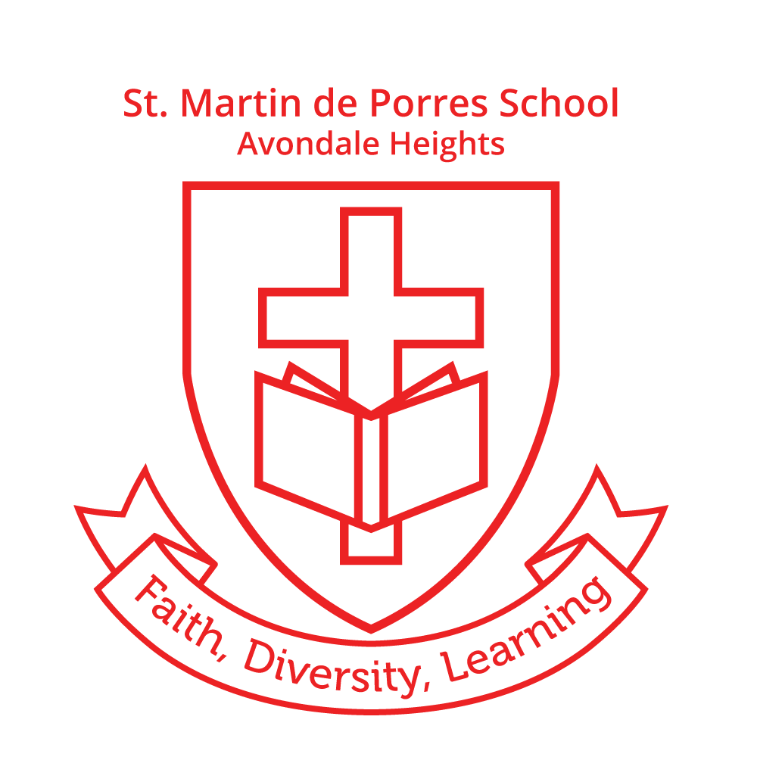
St. Martin de Porres School

Avondale Heights

GOVERNANCE & LEADERSHIP

RATIONALE

St. Martin de Porres School Avondale Heights was established by the Catholic Church in 1965 to service the educational needs of the catholic parishioners of Avondale Heights. As such, St. Martin de Porres school’s governance structure is determined via Church law, called Canon Law, interpreted and administered for the Church via the Canonical administrator of St. Martin de Porres parish and school, the Parish Priest.

Canon law sets the context for governance in our Catholic school :

In regard to the rights and responsibilities of the Parish Priest, Canon 515, 519, 532 803, 806, 800 and 822 state :

- A parish under the authority of the diocesan Bishop…. entrusted to a parish priest as its proper pastor.

- The Parish Priest as the proper pastor of the parish….so that he may carry out the offices of teaching, sanctifying and ruling with the cooperation….of lay members of Christ’s faithful….

- The Parish Priest, in all juridical matters, acting in the person of the parish, in accordance with the law.

- The Church having the right to establish and to direct schools for any field of study or of any kind and grade.

- In exercising their office, the pastors of the Church……are to make an ample use of the means of social communication….

In regard to the rights and responsibilities of the parish/school community, Canon 793, 796 and 806 state :

- Parents, and those who take their place, have both the obligation and the right to educate their children. Catholic parents have also the duty and the right to choose the means and institutes which, in their local circumstances, can best promote the catholic education of their children.

- The means of advancing education as fostering closest cooperation between parents and the teachers….teachers are to collaborate closely with the parents and willingly listen to them; associations and meetings of parents are to be set up and held in high esteem.

- Those who are in charge of Catholic schools are to ensure, under the supervision of the local Ordinary, that the formation given in them is, in academic standards, at least as outstanding as that in other schools in the area.

In applying and clarifying these canons more practically in schools, the Church authority for education, the Sacred Congregation For Catholic Education, wrote ‘The Catholic School’ in 1977, which makes such statements as, “…..following the principle of participation and co-responsibility, the various groupings which constitute the educational community are, according to their several competencies, to be associated in decision making concerning the Catholic school and in the application of decisions once taken;” “It is….essential…, for a unity in teaching, that each member of the school community, albeit with differing degrees of awareness, adopts a common vision…”

RATIONALE (cont.)

Further to this, in 1985, the Archdiocese of Melbourne produced its, ’Guidelines for Parish Education Boards’ which further clarified possible governance structures for Catholic schools in Melbourne and set the tone for the future, “For Boards, cooperation, collaboration, consultation and communication become the keynotes of the spirit and mode of operation… in achieving community participation in decision making.”

These guidelines clearly affirm the tenants of relevant Canon Law and other authoritative Church documents and provide a more formalised governance structure which involves the parish and school community. St. Martin’s parish school re-affirms that :

- The Parish Priest is, according to civil and canonical law :
~ the pastor in a parish community.
~ ecclesiastical administrator and manager of the parish primary school.

- The School Principal has co-responsibility for ensuring that the school operates effectively in the formation and care of its students and staff.

- The Parish Priest and Principal are, therefore, ‘ex-officio’ members of any parish primary school committees which deal with school development.

- Parents as the prime educators of their children have the right to be treated as equal members of the school community and share the responsibility of accomplishing school objectives.

- Community participation in decision making requires cooperation, consultation and open communication based on mutual respect and trust.

- The role of Education Boards need not be static, as the ability to provide informed, responsible advice depends on the stage of development of the Board, both collectively and individually.

- In order that advice given is informed, responsible and given in a unified way, Board members require formation and appropriate processes established for development.

- Education Boards are advisory by nature and therefore decisions and/or advice is made as a recommendation to the Parish Priest and Principal.

The Education Board can function in :

~ assisting the formation of School Policy.

~ assisting in the preparation of the school budget.

~ supporting the maintenance and improvement of school facilities and equipment.

~ planning for the future.

~ assisting in the selection of a lay principal.

~ collaborating with school parents’ auxiliaries.

~ developing school/community relationships.

Further clarification of the role of the school staff and the wider school community in appropriate Catholic school governance structures was prepared by the Australian Council for Educational Research for the Catholic Education Commission of Victoria in 2005 with the resource, ‘Leadership in Catholic Schools “ Development Framework and Standards of Practice’ which recognised that new kinds of school leadership and decision making processes, centred on student learning was now needed in schools and that standards-based professional development and accountability was needed to further develop leadership potential in schools. The major tenant was that school leaders needed to actively and collaboratively promote, maintain, enhance, advocate, facilitate, encourage and support the faith community, school vision, learning and teaching, people and resources and the wider school community challenges schools to develop more open and transparent governance structures within parish and school environments. This is also affirmed and reflected in the structure developed at St. Martin de Porres.

IMPLEMENTATION

Structure

Canonical Authorities ~
Archbishop of Melbourne
Melbourne Archdiocesan Catholic Schools Inc. (MACS)
Federal & State
Gov’t Funding
Authorities
National & International
Education
Authorities
C.E.C.V.
V.I.T.
V.R.Q.A.
Catholic Education Office
Melbourne
* School Advisory Board
* P & F Association
VIA
TREND DATA &
RECOMMENDATIONS
FUNDING & POLICY DIRECTIVES
POLICY DIRECTIVES & COLLABORATIVE DECISION-MAKING
JURIDIC AUTHORITY, MOSTLY
DELEGATED TO SCHOOL PRINCIPAL
PROVIDES STRATEGIC SUPPORT
ADVISORY & COLLABORATIVE
State Education
Authorities
MOSTLY
COLLABORATIVE

* St. Martin de Porres School
* School Principal
* Leadership Team

* School Staff

MOSTLY
COLLABORATIVE
DECISION MAKING
& DELEGATION OF ROLES &
RESPONSIBILITIES

ADVISORY & COLLABORATIVE

IMPLEMENTATION (cont.)

Governance Roles & Responsibilities

St. Martin de Porres Parent Handbook contains the function and membership of both the School Advisory Board and Parents & Friends Association. School Advisory Board Guidelines contain in detail the roles and responsibilities of Board members and the Parent & Friends Association Constitution contains detailed articulation of the roles and responsibilities of its membership. The school staff handbook contains detailed information on the roles and duties of all school staff, including those staff holding positions of leadership who therefore also form the ‘Leadership Team’ for the school.

Accountabilities

From : | To :
Parish Priest | Archbishop & MACS
School Principal | MACS & School Community
Deputy Principal | Principal
Faith, Liturgy & RE Leaders | MACS, Parish Priest & Principal
Literacy Leaders | Principal
Numeracy Leaders | Principal
Student Wellbeing Leader | Principal
Classroom & specialist teachers | Principal
Education support staff | Principal
School Advisory Board | MACS & Principal
Parent & Friends Association | MACS & Principal

School Improvement Framework

This system-wide framework was established for Catholic schools to develop their strategic direction every three to four years, reviewed on an annual basis and articulated as an annual action plan in identified education spheres : Education in Faith, Learning & Teaching, Leadership and Management, Student Wellbeing and School Community.

Through cyclic, annual review and formal evaluation every three to four years, prioritized education outcomes are identified in each sphere, targets set, improvement strategies identified and on-going monitoring documented.

The Principal, in partnership with the Leadership Team, (Deputy Principal and Leaders of Religious Education, Student Wellbeing and Curriculum) monitors the development of the Action Plan through facilitation of regular planning and development on designated staff development days held annually and via Professional Learning Team meetings held after normal school hours on a twice-weekly basis.

The Principal meets with this Leadership Team on a fortnightly basis to hear reports on progress in each position of leadership responsibility.

The Principal and Deputy Principal as ex-officio members of the Parent & Friends Association, meet with parents on a monthly basis to plan Social & Fund raising initiatives which support resourcing of the Annual Action Plan and which provide evidence of School Community initiatives.

The Principal, Deputy Principal and Parish Priest meet with the parent members of the School Advisory Board on a monthly basis to review school policy, develop new policy initiatives, provide advice on current and future school development proposals and to ensure action continues within the School Community sphere of the Annual Action Plan.

By the end of Term Two each year, the Principal also provides the school and wider community with its annual performance report, distributed to all families via the school website and distributed to the Catholic Education Office Melbourne, for up-loading to the ‘MySchool’ web-site.
IMPLEMENTATION (cont.)

Leadership Team

LEADER POSITION | CLASSIFICATION | RECIPIENTS
PRINCIPAL | As per Award | Mark Williams
DEPUTY PRINCIPAL | As per Award | Rodney Bryar
FAITH & LITURGY LEADER | POL 2 & time release | Debra Athaide
LITERACY & NUMERACY LEADERS | POL 2 & time release | Emily O’Connor (P-2)  Rodney Bryar (3-6)
STUDENT WELLBEING LEADER | POL 2 & time release | Andrea Fernandez

Support Team

LITERACY INTERVENTION | time release | Fiona Fogarty
NUMERACY INTERVENTION | time release | Alana Talia
eLEARNING | Outsourced | Source Central

Length of Term

- Re - Deputy Principal ~ initial four year term, then at the discretion of the Principal

- Re – Faith, Liturgy Leader ~ a minimum of two years, to be vacated for staff application dependent on staff expertise (i.e. - completion of an appropriate additional qualification)

- Re – Curriculum Leader ~ a minimum of two years, to be vacated for staff application dependent on staff experience & expertise

- Re – Student Wellbeing Leader ~ a minimum of two years, to be vacated for staff application dependent on staff expertise (i.e. - completion of an appropriate additional qualification)

School Executive Authority & ‘Chain of Command’

In the absence of the Principal, the Deputy Principal (Daniel Parnis) assumes all responsibilities delegated to the Principal by the Parish Priest.

In the absence of both of the above, limited Executive Authority is delegated to a member of the Leadership Team (and if all absent, senior teaching staff) to undertake decision making responsibility in cases of emergency (e.g. evacuation or invacuation) or where there might be parent or staff conflict or misconduct requiring ‘simple’resolution.

These people are listed below in order of ‘Chain of Command’ :

Rodney Bryar
Andrea Fernadez
Debra Athaide
Emily O’Connor
Maria Cotesta
Gracie Prencipe
Susan Sammut

EVALUATION

Reviewed every two years – 2013, 2015, 2017, 2019, Jan. 2021

